Family Event for Preschool and Headstart
Come meet our local community heroes!
When: Friday, October 18 at 12:00 at
Where: Shepherdsville Fire Station #1
634 Conestoga Pkwy, use fire side entrance

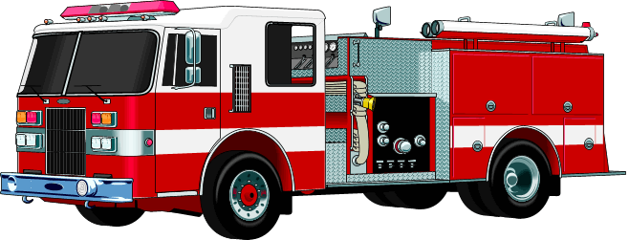
October is fire safety awareness month so families will receive great information regarding fire safety and Halloween safety! Children will get to meet local community helpers and everyone will have a blast!

Please send back the bottom portion of this paper so we know how many families to expect.
------------------------------------------------------------------------------

Student’s Name: __________________________
___ Yes, we will be attending; # of people attending ____
___ No, we will not be attending

